**VIVA IMR - One day Multidisciplinary National Conference “VISHLESHAN 2018”**

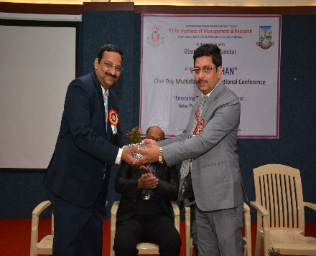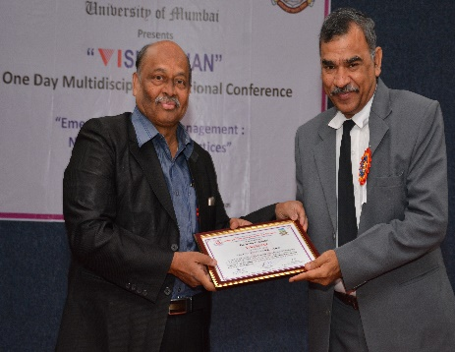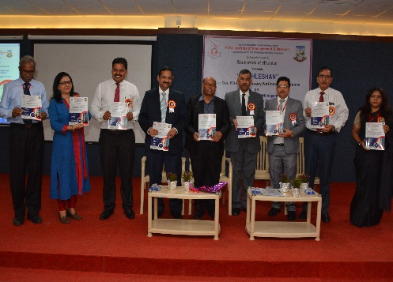

VIVA Institute of Management and Research, Virar (E) arranged a National Conference - ***“Vishleshan”*** in association with University of Mumbai on Saturday, 17th March 2018. The First half session started with the inauguration of the Journal followed by speeches of keynote speakers like Mr. S. N. Padhye, Trustee of VIVAIMR, expressed his views on disruptive technology and challenges in future, Mr. Brijesh Sharma – Superintendent, GST Intelligence, Government of India on Impact of Goods and Service Tax and future Job Opportunities by GST & Mr. Kishore Pradhan – CEO, Global Trade Consultancy & Co-Chairman ASSOCHAM Global Factoring forum highlighted on latest trends in management.

The post-lunch session mainly comprised of the presentations from professors and students of different colleges ranging topics from Film making, consumer behaviors, E wallets, etc. Evaluators for the day were Prof Dr. A.P.Pandey, Dr.G.D.Giri, Dr. Jayashree Mehta, and Dr.Samadhan Khamkar. And after the presentation “***The Best Paper Award***” was announced, followed by distribution of certificates and journals. All the participants & students participated enthusiastically & the rich mesmerizing experience would go a long way in shaping their careers.